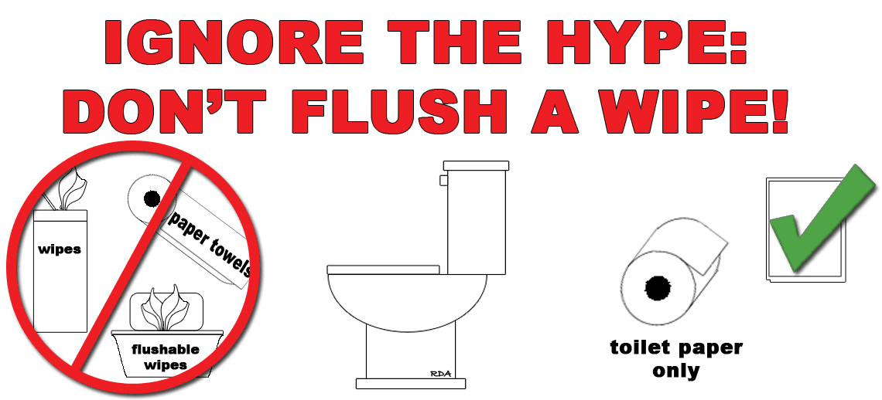
IMPORTANT SEWER SYSTEM NOTICE
The Borough of Lawnside has been experiencing operational problems with various sewage pumping stations throughout the Borough. The cause of the problem relates directly to the products and materials discharged from property owners to the Borough’s public sewer mains.
HARMFUL EFFECTS OF EXTRANEOUS DEBRIS DISCHARGED TO PUBLIC SEWER SYSTEM
Do NOT put paper products such as paper towels, moist towelettes, tissues, handy wipes, disposable towels, diapers, sanitary napkins, and feminine products down the drain. The only paper product that should be flushed is toilet paper. Kitchen solids, such as fruit and vegetable rinds and peels, corn kernels, eggshells and chicken bones can also cause blockage. Garbage disposals do not always reduce some of these items to the point that they will flush clear of the lateral lines.
Do NOT dump cooking grease and oils down the drain. Flushing out the grease with hot water will not work wither; this only causes a build up further down the drain and eventually contributes to a stoppage in the lateral or Town sewer pipes. Avoid using chemicals that claim to dissolve grease, such as vinegar and baking soda. Those products only dislodge grease clogs and move them further down the pipe, which can lead to similar problems. To dispose of cooking grease, pour it into a heat-resistant container, such as milk carton and allow it to cool and set. That container should then be disposed in the regular garbage. Please educate and encourage all members of the household to follow proper grease handling steps.
Financial Impact of Continued Discharge of Debris, Grease, Oils, and Fats
The continued discharge of extraneous debris and grease, oils and fats into the public sewer system will continue to increase costs for maintenance and repair of public sewer pipes and sewage pumping stations. Continued improper discharge of these materials could also incur additional costs for a homeowner because of the cleaning of laterals and basement flooding.
THERE IS AN EASY WAY TO PREVENT SEWER PROBLEMS AN IT BOILS DOWN TO ONE MAIN EFFORT: Do NOT put things down your pipes that should not go down them.
FOR MORE INFORMATION CONTACT THE BOROUGH OF LAWNSIDE DEPARTMENT OF PUBLIC WORKS AT 856 573-6212

